Members are summoned to the Pitcombe Parish Council Meeting to be held at 7.30pm on Thursday 20th September 2018 at Hadspen Village Hall.

Members are reminded that the Council has a general duty to consider the following matters in the exercise of any of its functions: Equal Opportunities (race, gender, sexual orientation, marital status, age and any disability) Crime & Disorder, Health & Safety and Human Rights.

Members of the public are invited to attend. The Chairman will allow a period of 10 minutes for questions from the public before the meeting begins.

- To receive Apologies for Absence.
- To receive Declarations of any Unregistered Disclosable Interests.
- To review Planning Applications
New Planning Applications:
- 18/02384/FUL - Erection of a museum building to partially cover and preserve archaeological remains, construction of replica Roman Villa (for museum use) and associated landscape works. Emily Estate (UK) Ltd, Land West of Cattle Hill, Welham, Castle Cary
- 18/02459/FUL – The formation of a new access road to Shatwell Farm. Land OS 0041 Shatwell Lane, Yarlington
- Finance.
- To approve payments of:
Wendy Crane | Materials for telephone box maintenance | £110.35
- Any Other Business:
Please note this item can only be used for statements of information and requests for items to be included on the agenda at the next meeting.
- Date of the next Parish Council meeting: 9th October 2018 at 7.30pm

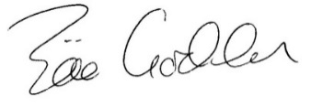
Zöe Godden
Parish Clerk
16th September 2018

